**INDEPENDENT PROJECT REPORT**

**NAME: L SREE LALITH KARTHIK**

**R.NO: CS23B1042**

**Introduction**

Through my project, I tried to integrate some of my fondest childhood memories with a few skills that I've acquired over this past year. I am making a few nostalgic games in Python and some of its modules, alongside a website, which was made using Bootstrap, HTML and CSS; everything themed a specific way – Harry Potter. This is just the beginning of what I’ve envisioned, and it has a much larger scope than focusing on a single franchise.

**Motivation**

Considering the fact that many of us forget what we used to love and spend most of our time on during our childhood, the motivation behind taking this topic is to provide a spot for enthusiasts of specific franchises or genres to enjoy and recollect their nostalgia. Just for a while, it can become a spot for people to get back from their mundane jobs and harsh realities of the world to embrace their childhood memories. It can be a potential place to fall back, relax, and spend time on, enjoying the nostalgia and burden-less excitement of our childhood.

**Problem and my project**

It's been a while since Harry Potter has ended, but there has been no reduction in the fandom whatsoever, and this is the case with several amazing franchises. Through the years, several amazing websites have come up, but there are a few issues with most of them. After a certain time, their appeal becomes quite diminished, as they become more repetitive, causing lack of interest. This is where a few features I have added to my own website come in. I have attempted to resolve this by making my own set of codes in order to create a set of themed games, quizzes and also a simple website. I think introducing a competitive aspect, either with the player themselves, or with other people on a global level, making it multiplayer, will make such websites or games much more engaging and less repetitive. Thus, I made a few original games and an interactive website with quite a few sections for people to explore. The website not only holds a home page, and an about section, but it also consists of a few databases through which people can go through to find out more about elixirs, spells and wizards and witches of the Harry Potter franchise, a quiz section which holds a few quizzes for them to attempt, and also a summaries section, which can be explored by people who are in a dilemma whether to take up the series or not and who don’t mind some spoilers, or even by fans who might not want to read the whole thing again, but definitely want to get back to the experience of reading the franchise, as this section would allow them to reminisce those times.

**Procedure**

Here is everything I followed while making this project, step-by-step:

* Firstly, I created the ‘Basilisk game’, which is quite a simple and common project, using the turtle module on python, which relies on Object oriented programming. I tried to make the game as Harry-Potter related as I could.
* I started working on a website that could consist of other things like information, some side stories which were not covered in the books, etc. I chose a Bootstrap template and started working on it, making quite a lot of changes, and trying to make it apt for my own topic. I finished working on the home page and set out for the rest of the website.
* I then started searching on API keys available which I could use to display information about a few things in the franchise, and implemented them in the website.
* I worked on creating a few quizzes that a user could play on the website, and this was done using an external website.
* I added a lot of informative webpages, making them part of the website, consisting of either summary, side stories, other information etc.
* I touched up the website with some other features like search bars, navigation buttons, inter connecting all the pages, web pages to deal with errors, etc.
* I also worked on another game, Quidditch-Keepers, which is modelled after the original game Pong. I used tkinter and object-oriented programming for this game.

**Novelty**

There are quite a few websites which work on a specific theme and might offer quizzes and also a few games. While I've taken inspiration from some of them, my idea of the website is different from others and it is a novelty. Every website is unique and each of it has its own unique selling point which differentiates it from all the remaining ones in that particular genre. I believe my website is unique and different from others, and one of the main factors contributing to that is it being made in a way that I find most appealing as a fan. This website can be said to be by fans for fans. The best way to develop such a website, which so heavily relies on the fandom, is to look at it from the perspective of the fandom, which would enable us to think about what features exist in other websites, what more features we want and also what are the expectations from an ideal themed website.

**Technology used**

I’ve used quite a few features and modules of python alongside some web development tools and a couple of external websites. They are:

* Bootstrap
* Python
* Turtle
* Tkinter
* Jinja
* Flask
* Html
* Css
* A few open-source Api keys
* External websites – Canva (logo) and Typeform (quizzes)

**Diagram/Flow chart**

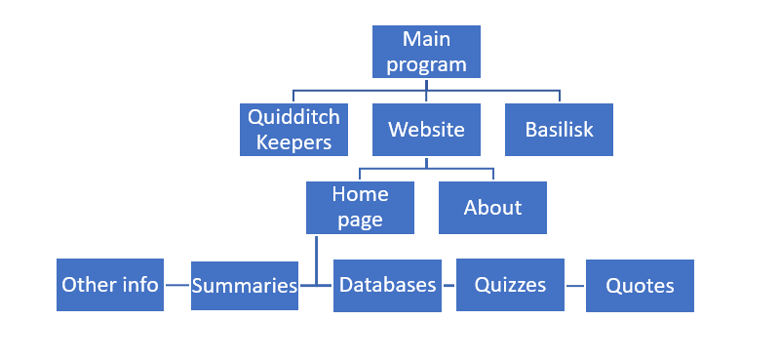

**Drawbacks and future aims**

There are a few drawbacks I’ve observed in my own project that I have noticed and intend to work upon. They are:

* I am unable to include the games in the website itself, and if a person viewing only the website would like the play the games, the prerequisite of them having a working knowledge of Python cuts down the audience quite a bit.
* I am using an external website to create the quizzes, rather than being having them present on the website locally. This creates issues such as limits on the number of responses, potential issues if the external source changes a few rules, etc.
* Currently, users cannot save their progress on the website. Once u close and re-run the website, all your progress is gone, be it sorting quizzes or other scored quizzes. While some people might want this to happen, trying to get the fun out of it another time, the same cannot be said out of everyone.

Here is my plan and vision for the future of the website, if I would have had a chance to work on it further:

* Develop it better using better backend programming languages like JavaScript, which will enable me to not only include the games, but also the quizzes on the website.
* Also trying to include features like history, saving, providing a choice to the users to retake quizzes, while at the same time saving their progress, etc.
* Adding leaderboards to the quizzes, according to friends or houses, would increase the competition, creating more interest amongst the users.
* Add more engaging and interesting side stories, presented in a better way, giving users some nice reading material, related to their favourite franchise.
* As it is currently, the website is not good enough to attract as much attention as would be ideal. But, having more features, expanding the audience by focusing on more than just Harry Potter, and trying to focus on the above problems might be a good way to get started on that.

**Scope**

Though the only theme I have considered in this project is of Harry Potter, the scope of this project is much larger. With enough time, I would like to expand this project to comprise of several other genres and franchises with thriving fandoms, such as anime in general, or a franchise like Star Wars in particular, and also trying to include the games within the website rather than people being forced to try some coding in order to play, while at the same time providing open-source codes for these themed games, which will definitely be enjoyable for people who are into coding. This expansion will enable more people, who are into different franchises, to have a go to place to enjoy and get back to their nostalgic childhood fictional fantasies. Expanding the audience this way would bring quite a lot of traffic to the website, if it was made public.